Sri Staya sai Hospital :
1.G-Block-Karuna – 10-12-2025
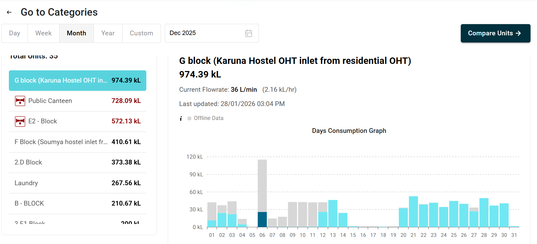

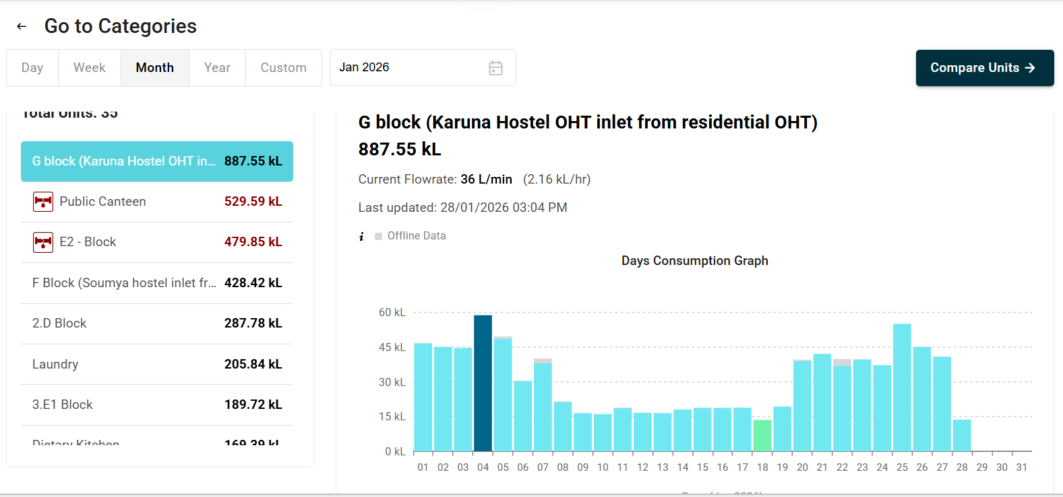

Details :
1.Module Used – Sim Module with SD Card Module
2.Device id - sssh_26
3. Unit id - FG24031F
4.Slave Id - 1

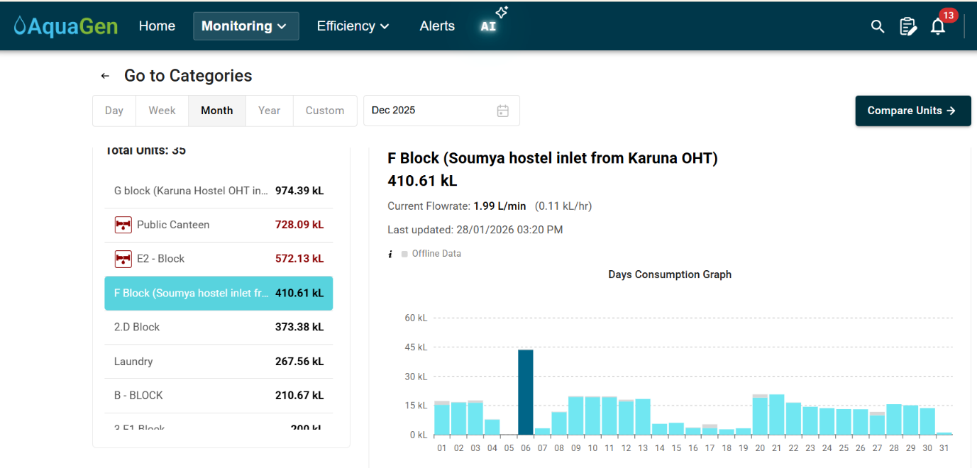
2.F-Block Soumya – 10-12-2025

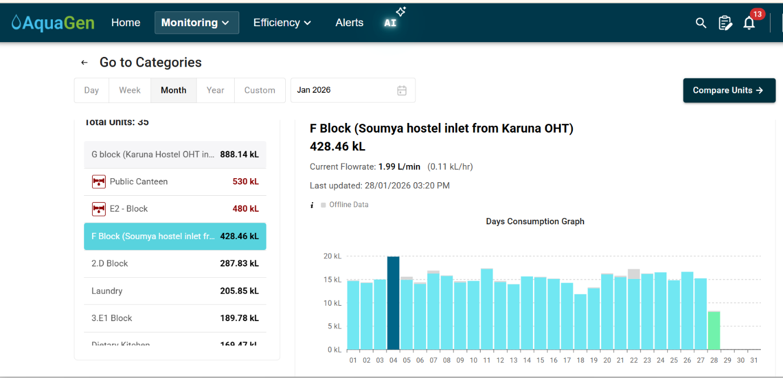

Details :
1.Module Used – Sim Module with SD Card Module
2.Device id - sssh_26
3. Unit id - FG24030F
4.Slave Id - 10
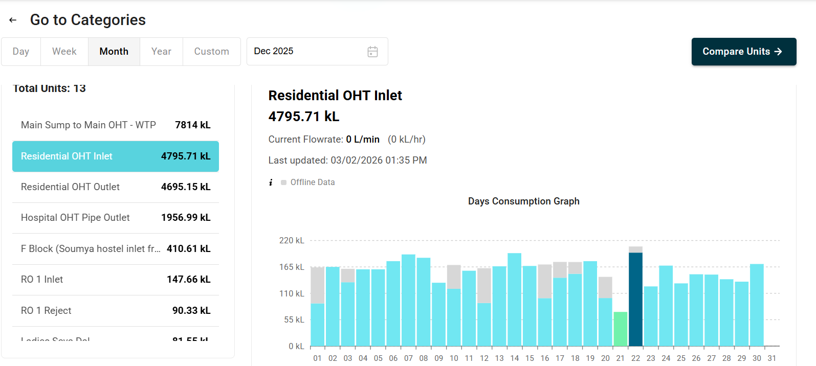
3.Residential OHT Inlet – 10-12-2025

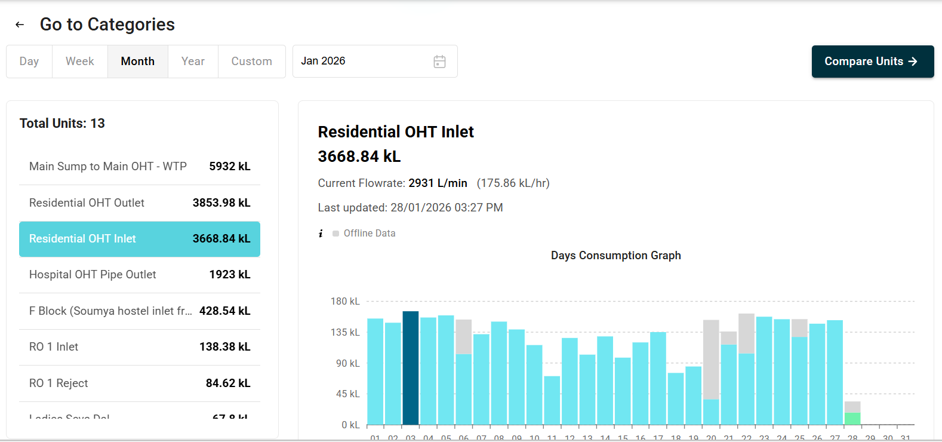

Details :
1.Module Used – Sim Module with SD Card Module
2.Device id - sssh_24
3. Unit id - FG24027F
4.Slave Id - 1

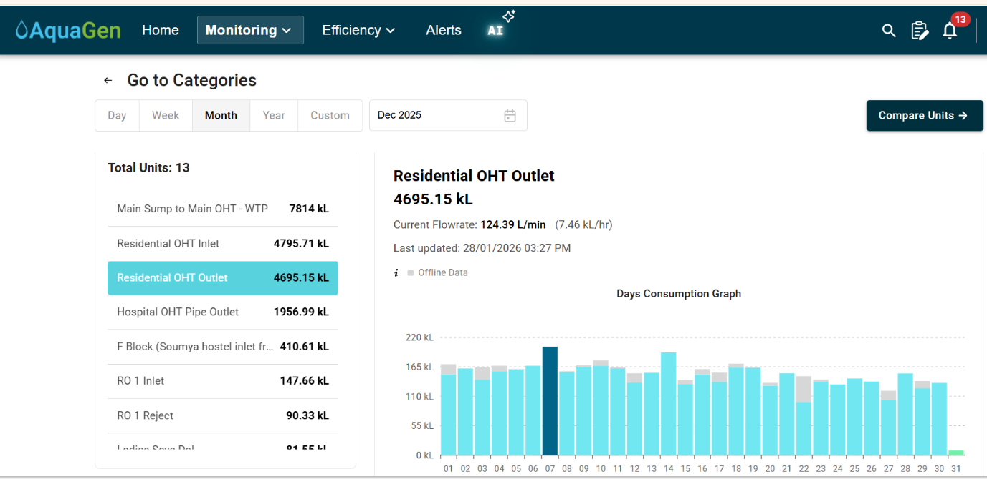
4.Residential OHT Outlet – 10-12-2025

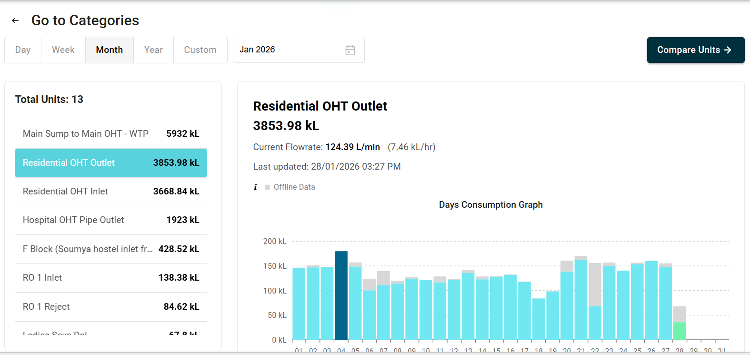

Details :
1.Module Used – Sim Module with SD Card Module
2.Device id - sssh_24_1
3. Unit id - FG24028F
4.Slave Id - 2

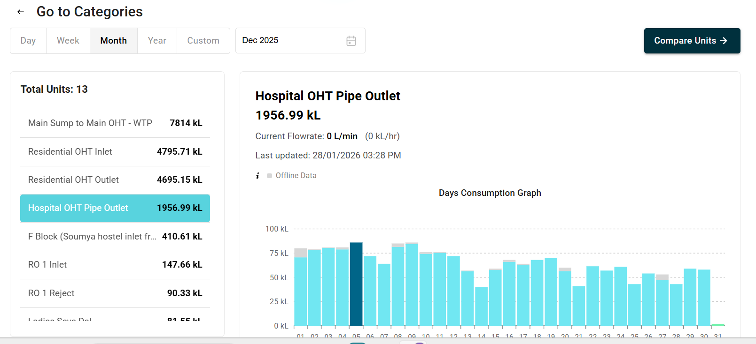
5.Hospital OHT pipe Outlet – 10-12-2025

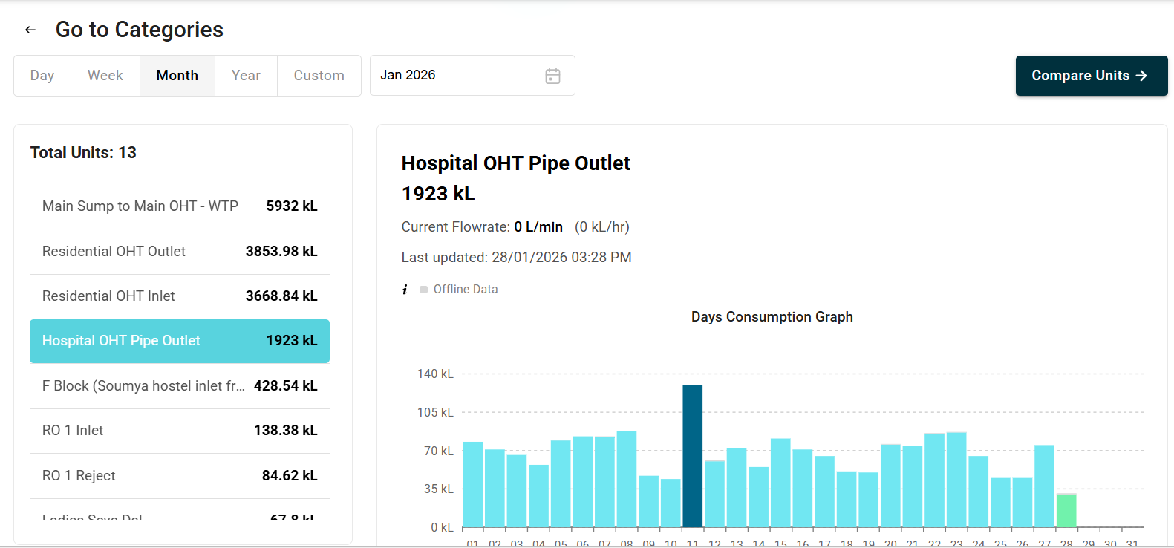

Details :
1.Module Used – Sim Module with SD Card Module
2.Device id - sssh_25
3. Unit id - FG24029F
4.Slave Id - 1
St Martha Hospital :
1.BWSSB Ref Meter – 12-12-2025
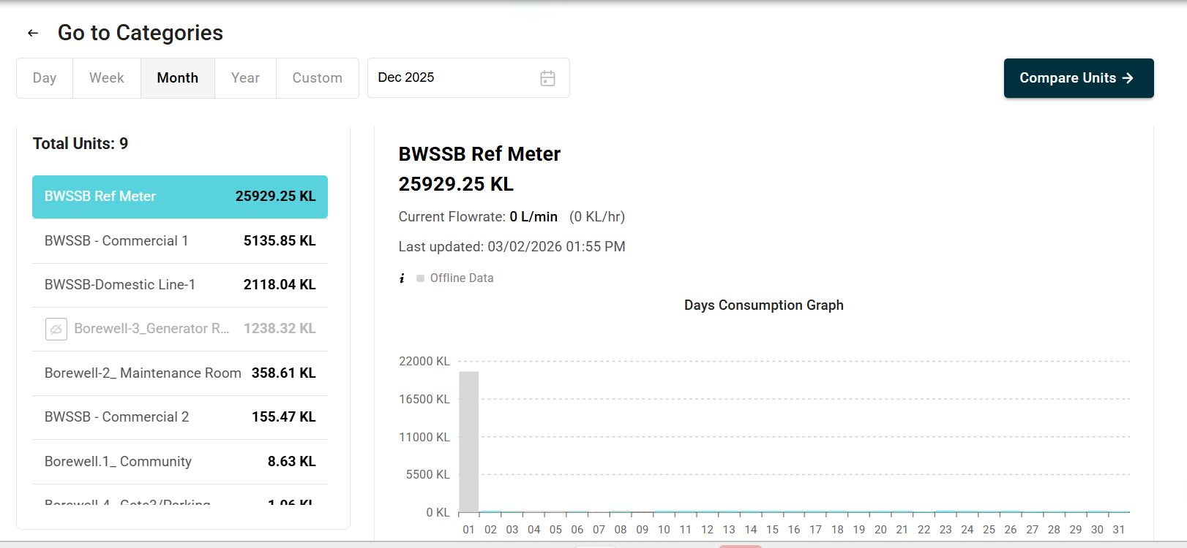

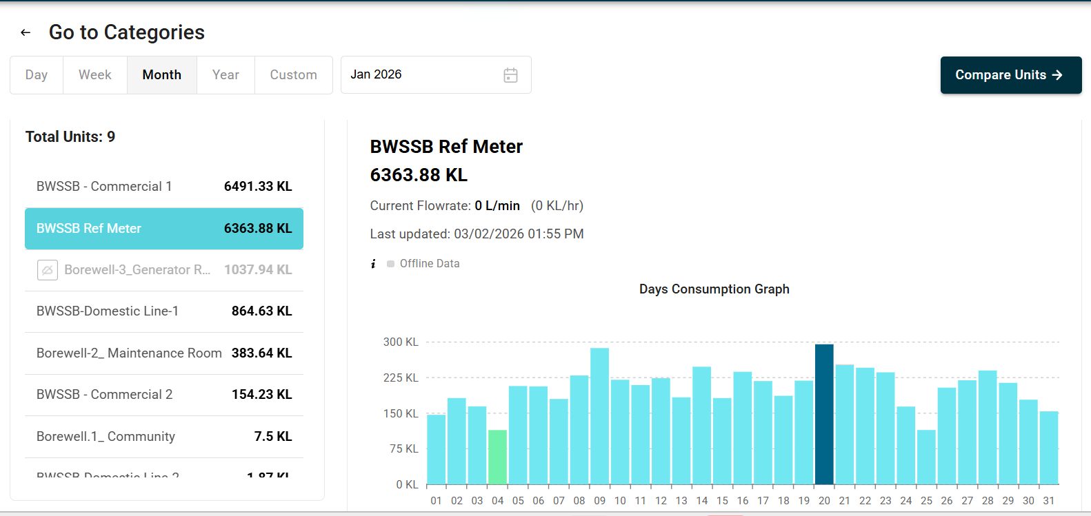

Details :
1.Module Used – Sim Module with SD Card Module
2.Device id - stmh_1
3. Unit id - FG24679F
4.Slave Id - 1

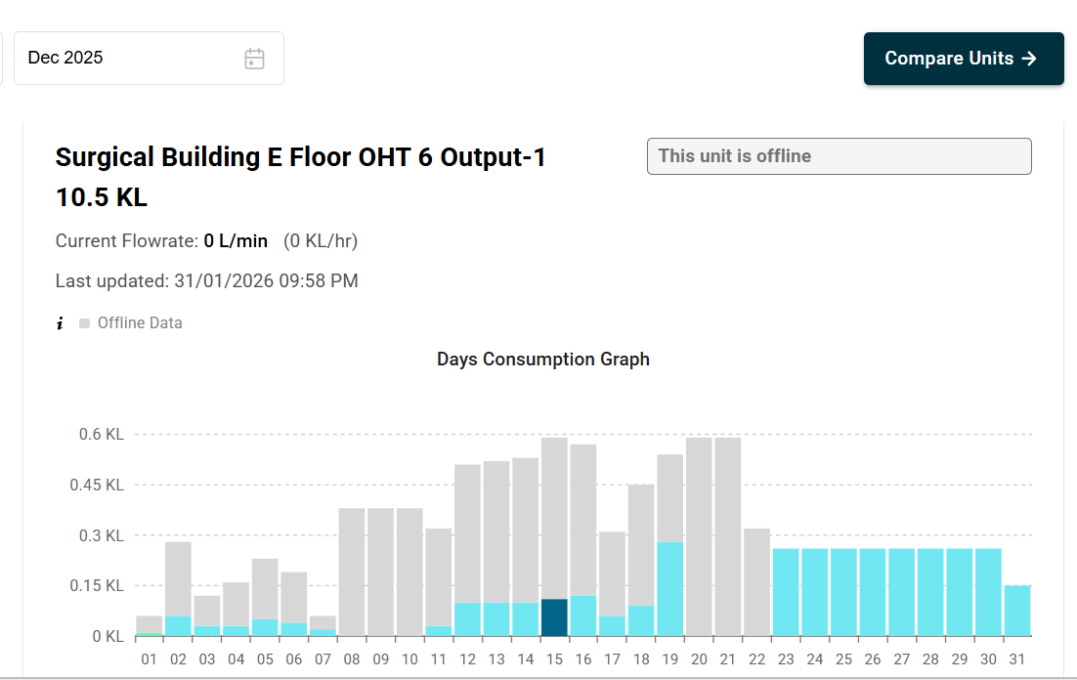
2.Surgical Building E Floor OHT 6 Output-1 – 31-12-2025

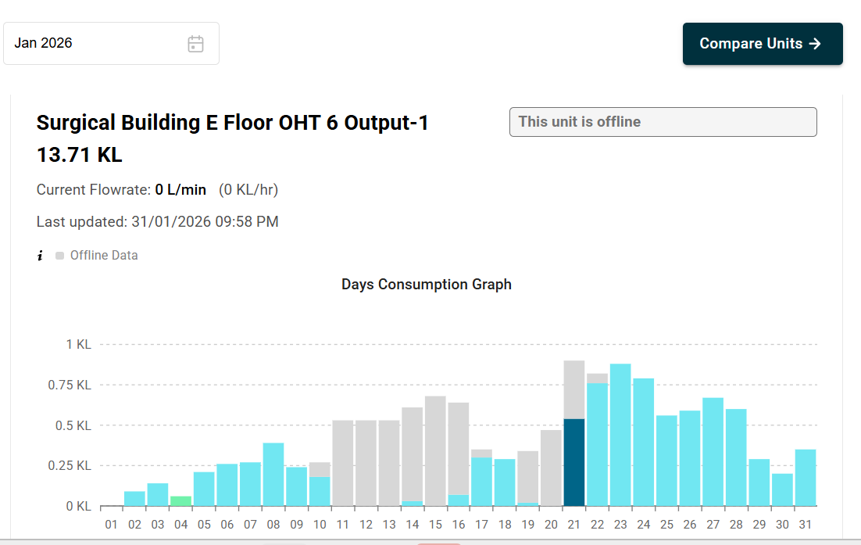

Details :
1.Module Used – Sim Module with SD Card Module
2.Device id – stmh_11
3. Unit id - FG24703F
4.Slave Id - 3
3.Surgical Building E Floor OHT 6 Output-2 – 31-12-2025
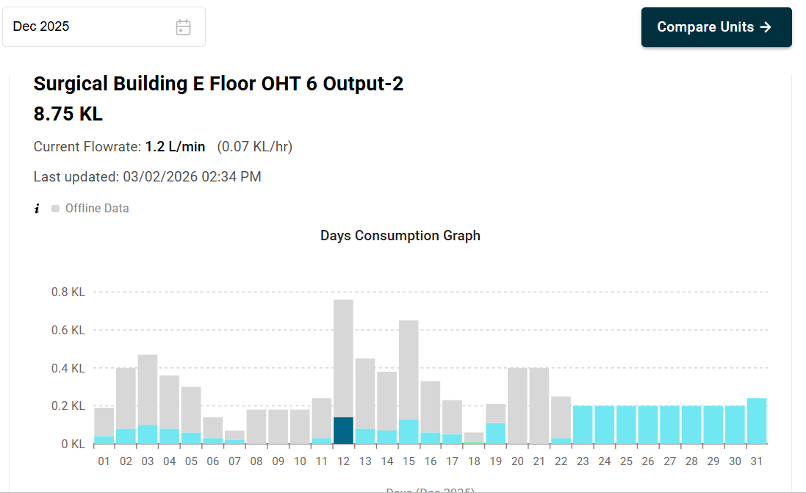

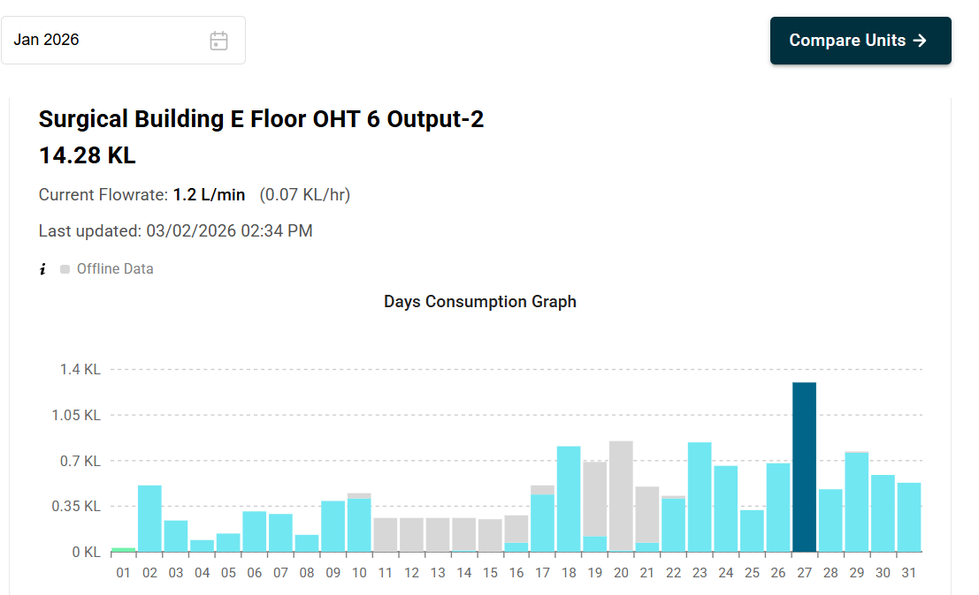

Details :
1.Module Used – Sim Module with SD Card Module
2.Device id – stmh_11
3. Unit id - FG24704F
4.Slave Id - 4
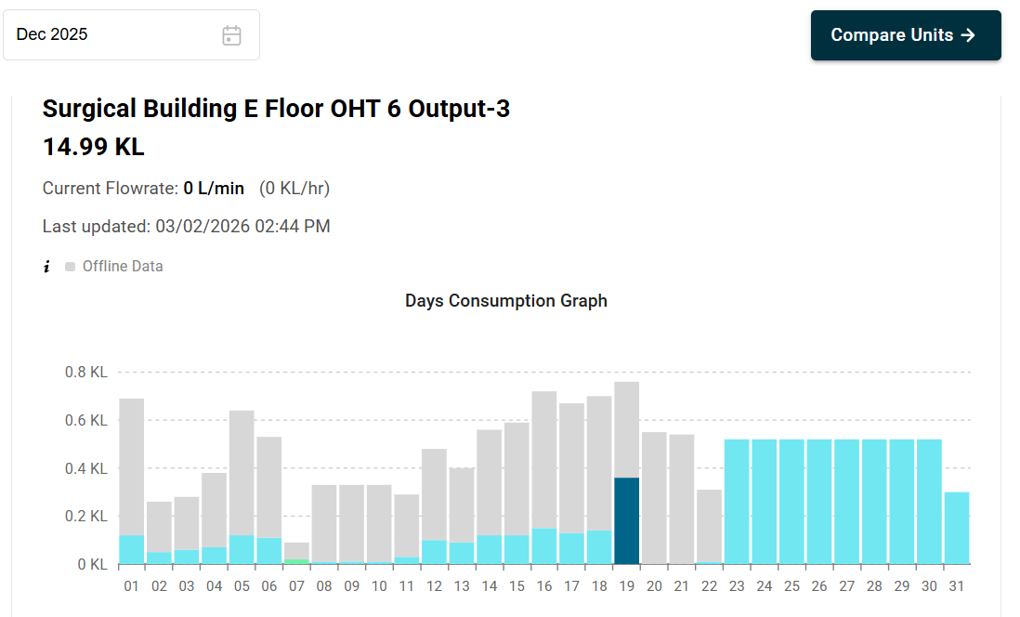
4.Surgical Building E Floor 6 Output-3 - 31-12-2025

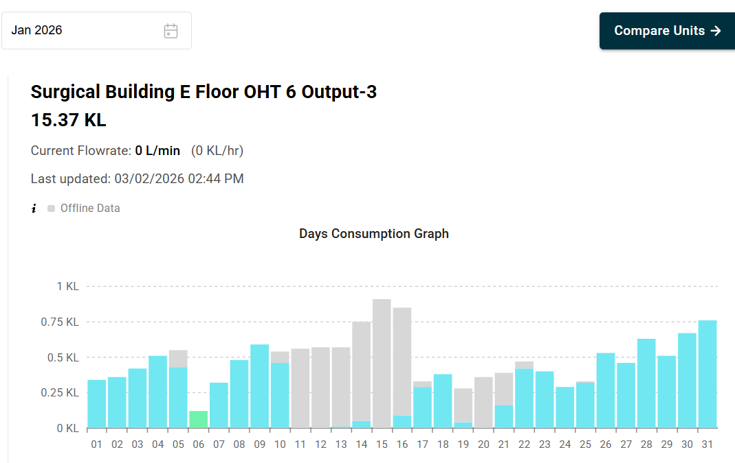

Details :
1.Module Used – Sim Module with SD Card Module
2.Device id – stmh_11
3. Unit id - FG24707F
4.Slave Id - 7
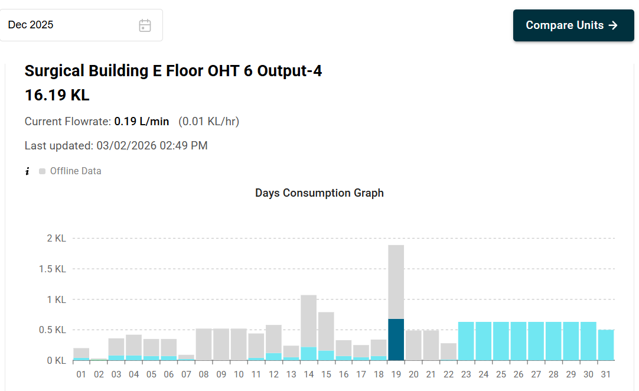
5.Surgical Building E Floor OHT 6 Output -4 - 31-12-2025

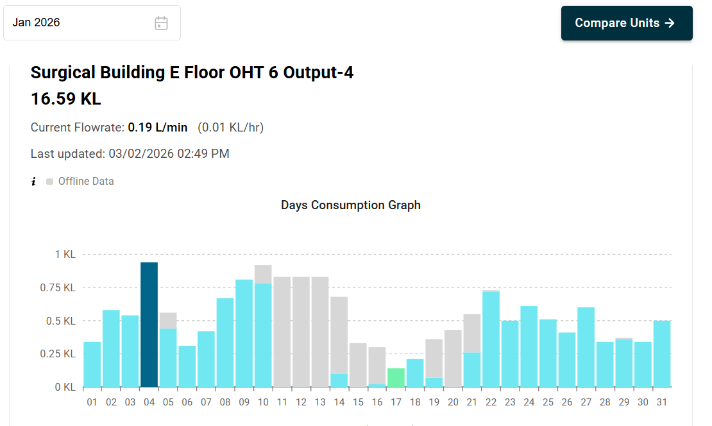

Details :
1.Module Used – Sim Module with SD Card Module
2.Device id – stmh_11
3. Unit id - FG24708F
4.Slave Id - 8
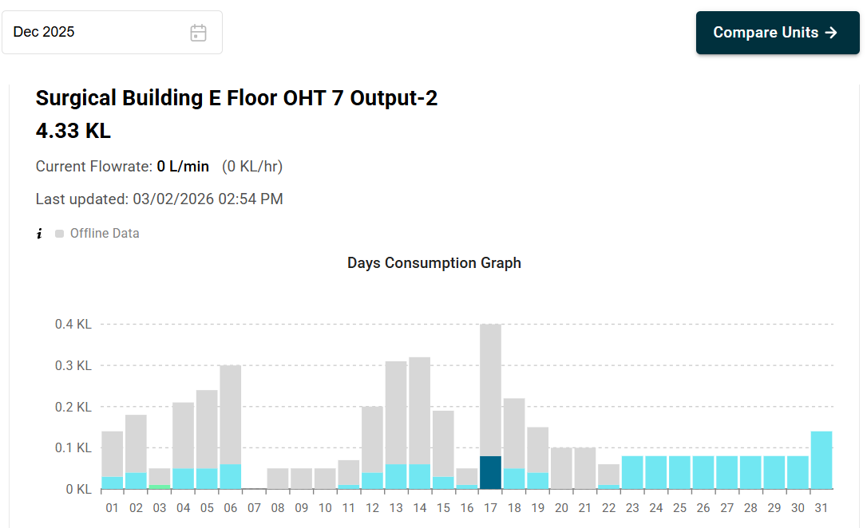
6.Surgical Building E Floor OHT 7 Output -2 - 31-12-2025

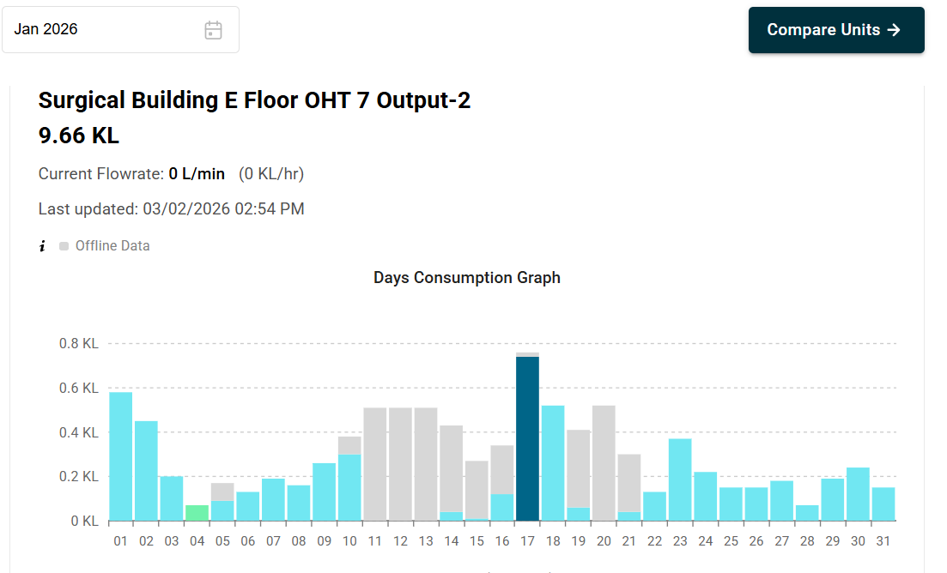
Details :
1.Module Used – Sim Module with SD Card Module
2.Device id – stmh_11
3. Unit id - FG24702F
4.Slave Id - 10
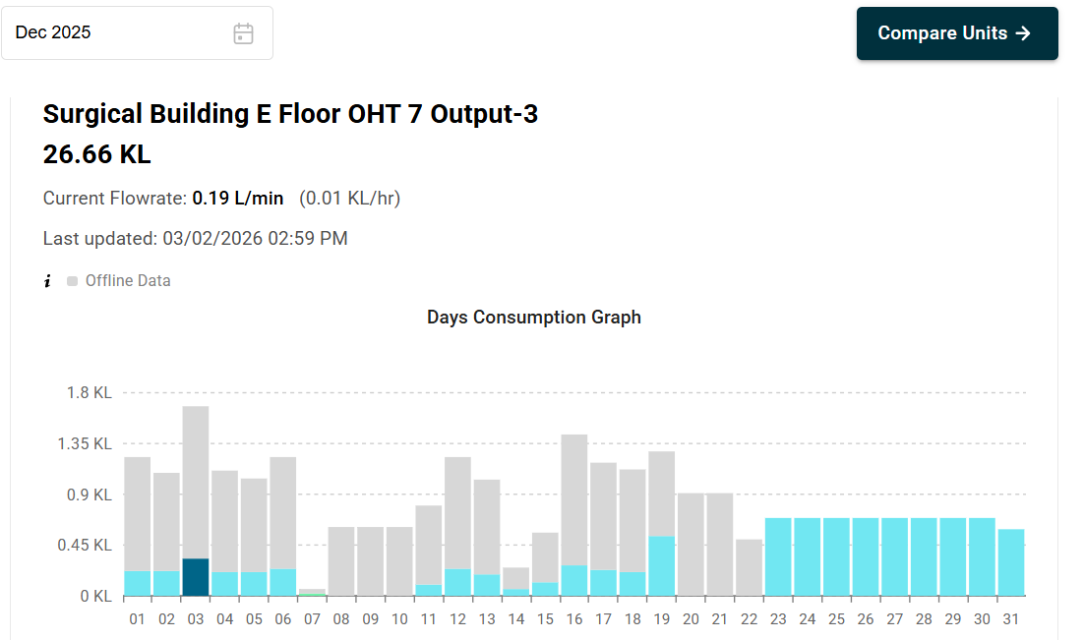
7.Surgical Building E Floor OHT 7 Output -3 - 31-12-2025

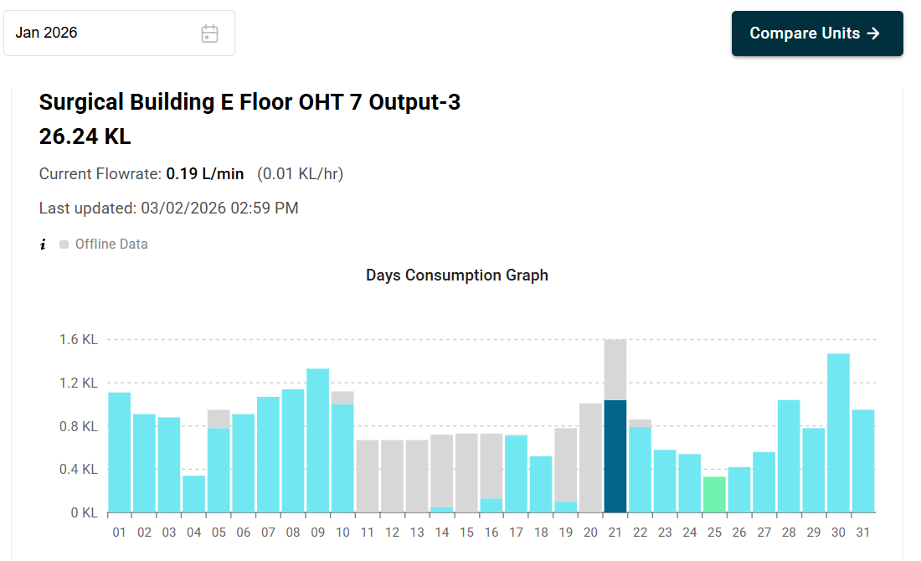

Details :
1.Module Used – Sim Module with SD Card Module
2.Device id – stmh_11
3. Unit id - FG24705F
4.Slave Id - 5
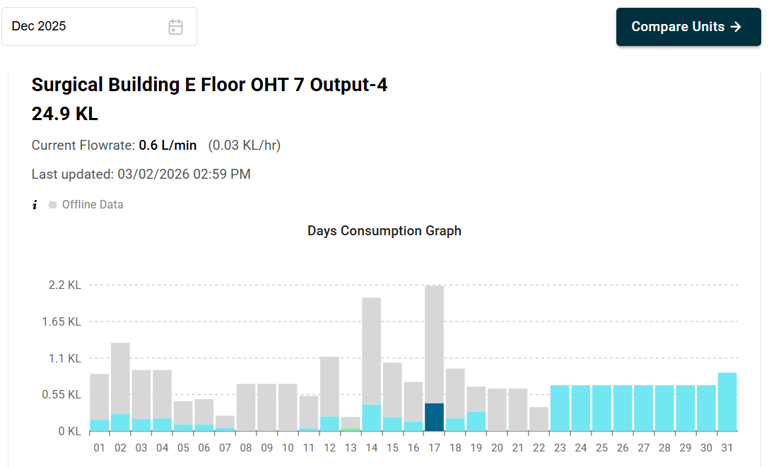
8.Surgical Building E Floor OHT 7 Output -4 - 31-12-2025

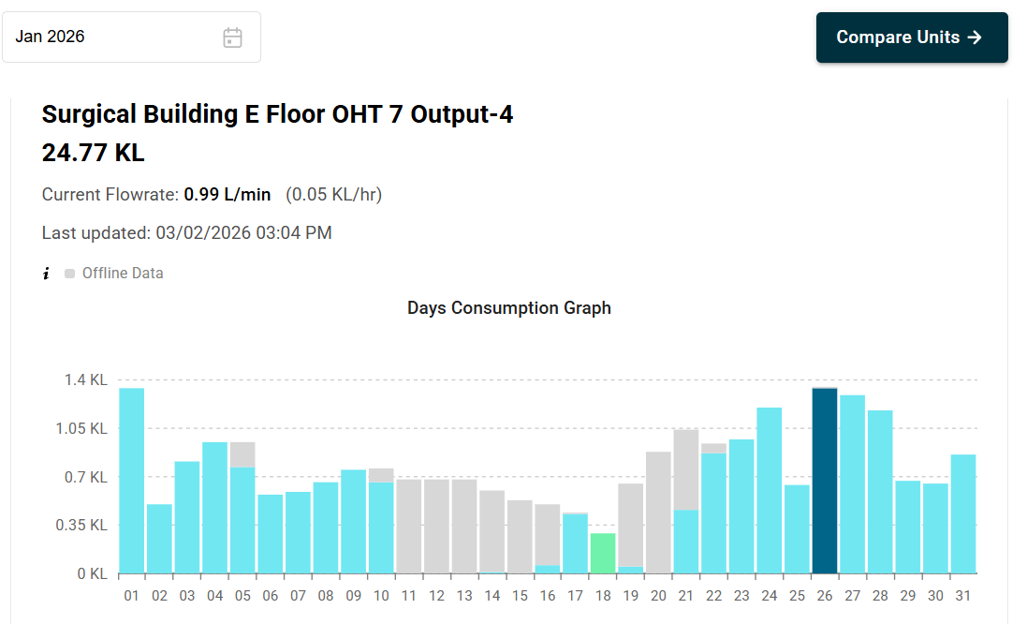

Details :
1.Module Used – Sim Module with SD Card Module
2.Device id – stmh_11
3. Unit id - FG24706F
4.Slave Id - 6

